SESSION-20

TASK-1
Create a table comparing Agile and Waterfall models across 5 factors relevant to software testing, such as requirements, feedback cycle, tester involvement, documentation, and flexibility.
ANSWER:
Factor | Agile | Waterfall
Requirements | Requirements can change during development | Requirements are generally finalized at the beginning
Feedback Cycle | Frequent feedback is taken during each Sprint | Feedback usually comes after a major phase or near the end
Tester Involvement | Testers are involved throughout the development process | Testing mainly starts after development is completed
Documentation | Focuses on necessary and useful documentation | More detailed documentation is generally prepared
Flexibility | Highly flexible; changes can be handled during development | Less flexible because changes can affect completed phases

Conclusion
Agile supports continuous testing and feedback, while Waterfall follows a more sequential testing approach.

TASK-2
Pick any app you use daily (like Instagram, Zomato, or Paytm) and describe how the testing process would look different if the team used Agile instead of Waterfall. Mention at least 3 specific testing activities or practices that would change.
ANSWER:
Application: Instagram-like app
If the team uses Agile, testing would happen continuously during development instead of waiting until the whole application is completed.
Three major changes
1. Testing happens during every Sprint
For example, if a new Story feature is developed in a Sprint, the tester can design and execute test cases during the same Sprint.
2. Continuous feedback
Testers can report defects immediately to developers, instead of waiting until the entire application is ready for testing.
3. Frequent regression testing
Whenever a new feature such as Reels or Stories is added, previously working features such as Login, Profile and Feed can be checked again to ensure they still work.
Conclusion
With Agile, testing becomes a continuous activity involving testers, developers and the team throughout development.

TASK-3
Draw a simple workflow diagram showing the main roles (such as Scrum Master, Product Owner, Development Team, Tester) and ceremonies (like Sprint Planning, Daily Standup, Sprint Review) in a SCRUM process.
ANSWER:
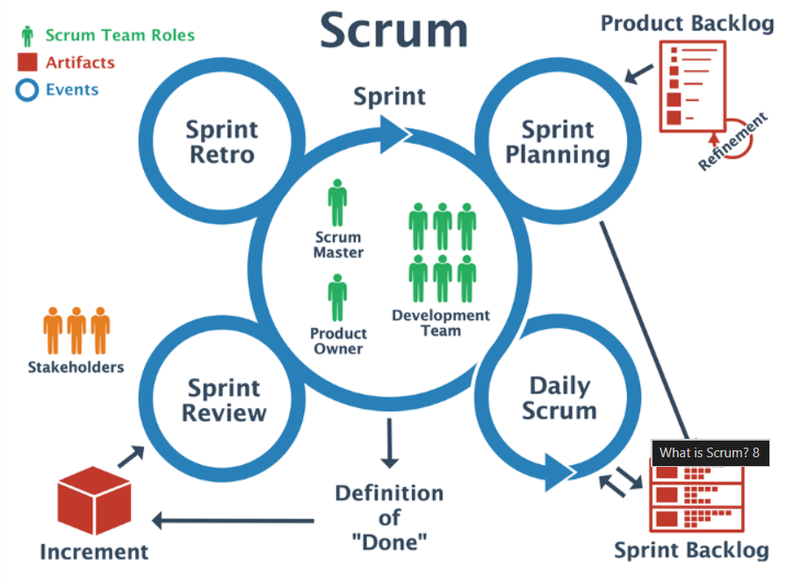
Main Roles
- Product Owner: Manages and prioritizes product requirements/backlog.
- Scrum Master: Facilitates Scrum activities and helps remove blockers.
- Development Team: Develops the required features.
- Tester/QA: Designs and executes tests and reports defects.
Main Ceremonies
- Sprint Planning: Decide what work will be done in the Sprint.
- Daily Standup: Team discusses progress, plans and blockers.
- Sprint Review: Demonstrate completed work and collect feedback.
- Sprint Retrospective: Discuss what went well and what can be improved.
TASK-4
For a food delivery app (like Swiggy), map out which testing activities should happen during each phase of a typical Agile sprint (e.g., backlog grooming, sprint planning, development, review).
Hint: Include activities like writing user stories, test case design, test execution, and bug reporting.
ANSWER:
Sprint Phase | Testing Activities
Backlog Grooming / Refinement | Understand requirements, clarify doubts, identify acceptance criteria, identify possible test scenarios
Sprint Planning | Discuss testing effort, identify testing tasks, estimate test work and plan test coverage
Development | Write test cases, prepare test data, review requirements, perform testing as features become available
Test Execution | Execute functional test cases, perform exploratory testing, report defects and verify fixes
Bug Fixing & Retesting | Retest fixed defects and perform regression testing on related functionality
Sprint Review | Verify completed user stories against acceptance criteria and support the team during demonstration
Sprint Retrospective | Discuss testing issues, identify improvements and suggest better testing practices for the next Sprint

Example
Suppose the Sprint includes a “Apply Coupon” feature:
Backlog → Understand coupon rules → Sprint Planning → Design test cases → Developer builds feature → Execute tests → Report defects → Retest fixes → Regression → Sprint Review
Conclusion
In Agile, testing is not a separate final phase. QA activities are performed throughout the Sprint so that defects can be found and fixed early.

